

Light in the darkness

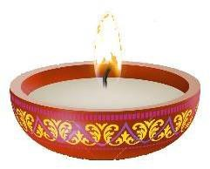

Let’s light up Headington’s residential streets
We need the warmth of light and the brightness of hope in winter’s dark days

If you can, we urge you to bring light to your neighbours by
- lighting your windows, front gardens and street trees

To encourage you, a free set of lights (batteries included) can be obtained from headington.action@gmail.com (subject to availability)

Four major faiths have festivals of light between Nov 4 and Jan 7 and there are the secular Christmas traditions too. Celebrate by keeping your lights twinkling through November, December and early January.

For your diary, Headington Action events
November 19. Lights in the natural trees in the shopping area switched on (without ceremony)
December 4. From 4.30. The Christmas Tree will be switched on. There will be music and food!!!
For more details see www.headingtonaction.org

