Headington Quarry History Group

‘Let the children play.’

A local history evening to celebrate childhood in Quarry.
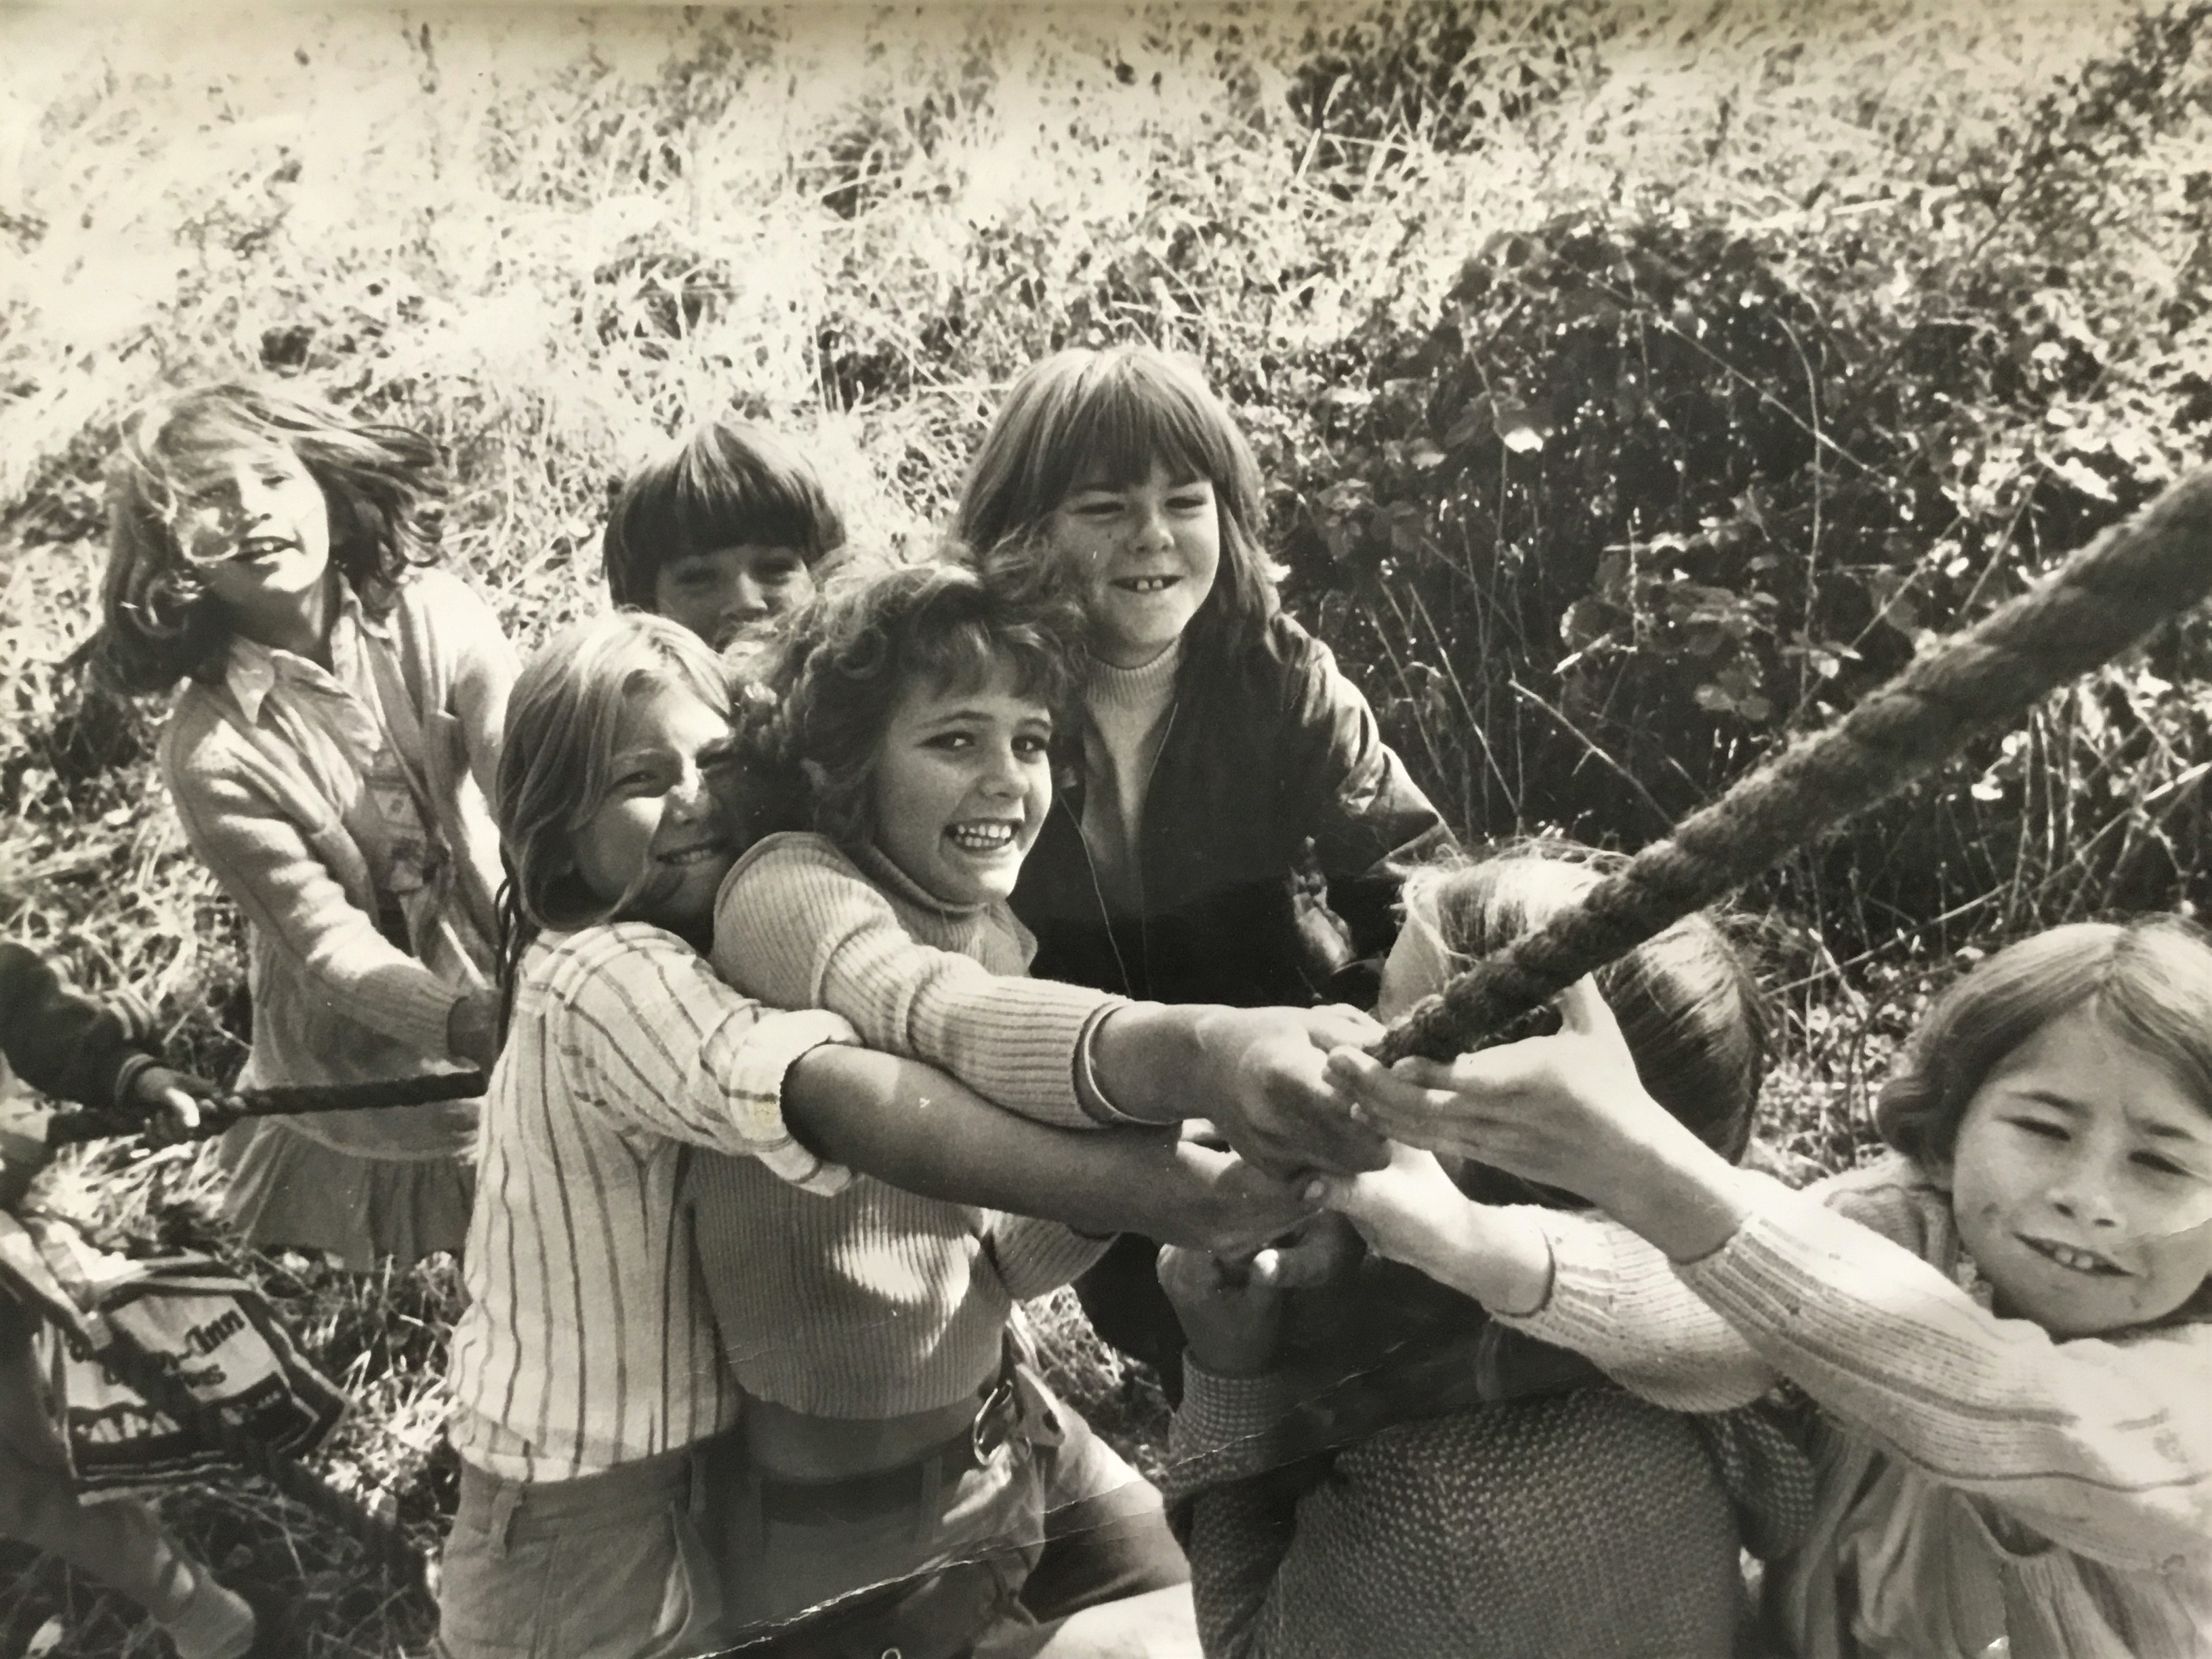

Did you grow up playing in ‘Muntsies’?

Did you attend the summer playschemes in Quarry Hollow Park?
Did you go along to the St Christopher’s Youth Club at Holy Trinity?

Were you in the Quarry cubs, brownies, scouts, or guides?

When - Thursday 14th September – 7pm
Where - The Masons Arms Pub function room – 2 School Place OX3 8LH
A local history event with photo displays, and an illustrated talk. All welcome.

